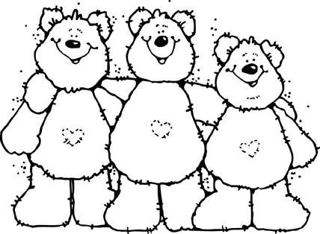
Better Together Rubric

Central Idea: A person’s character and attitude can affect relationships with friends
Task: Student creates a poster showing friendship and a complete sentence identifying character trait(s) displayed by the “friends” – visual can be photo, drawing, painting, etc. The written component needs to be specific, explaining the action and character trait(s) portrayed.
Criteria | Well Below | Below | Meeting | Above
Visual Aid | Incomplete project | The image doesn’t match the explanation. Some elements are missing. | The visual aid contains an image, a written explanation, is neat, and error free. | The visual aid is completed Independently, shows creativity and is neatly organized and error free.
Identification of a Learner Profile, Attitude, or Character Trait(s) | No explanation | The character trait or explanation doesn’t relate. | Character trait is identified and has a matching explanation. | Character trait is identified and additional examples are included.
Presentation | Student is unable to present poster or acts inappropriately. | Presents poster with minimal eye contact, and is difficult to hear or understand. | Presents poster with a clear voice and makes eye contact most of the time. | Presents the poster with confidence and poise, a clear voice, and makes eye contact.

